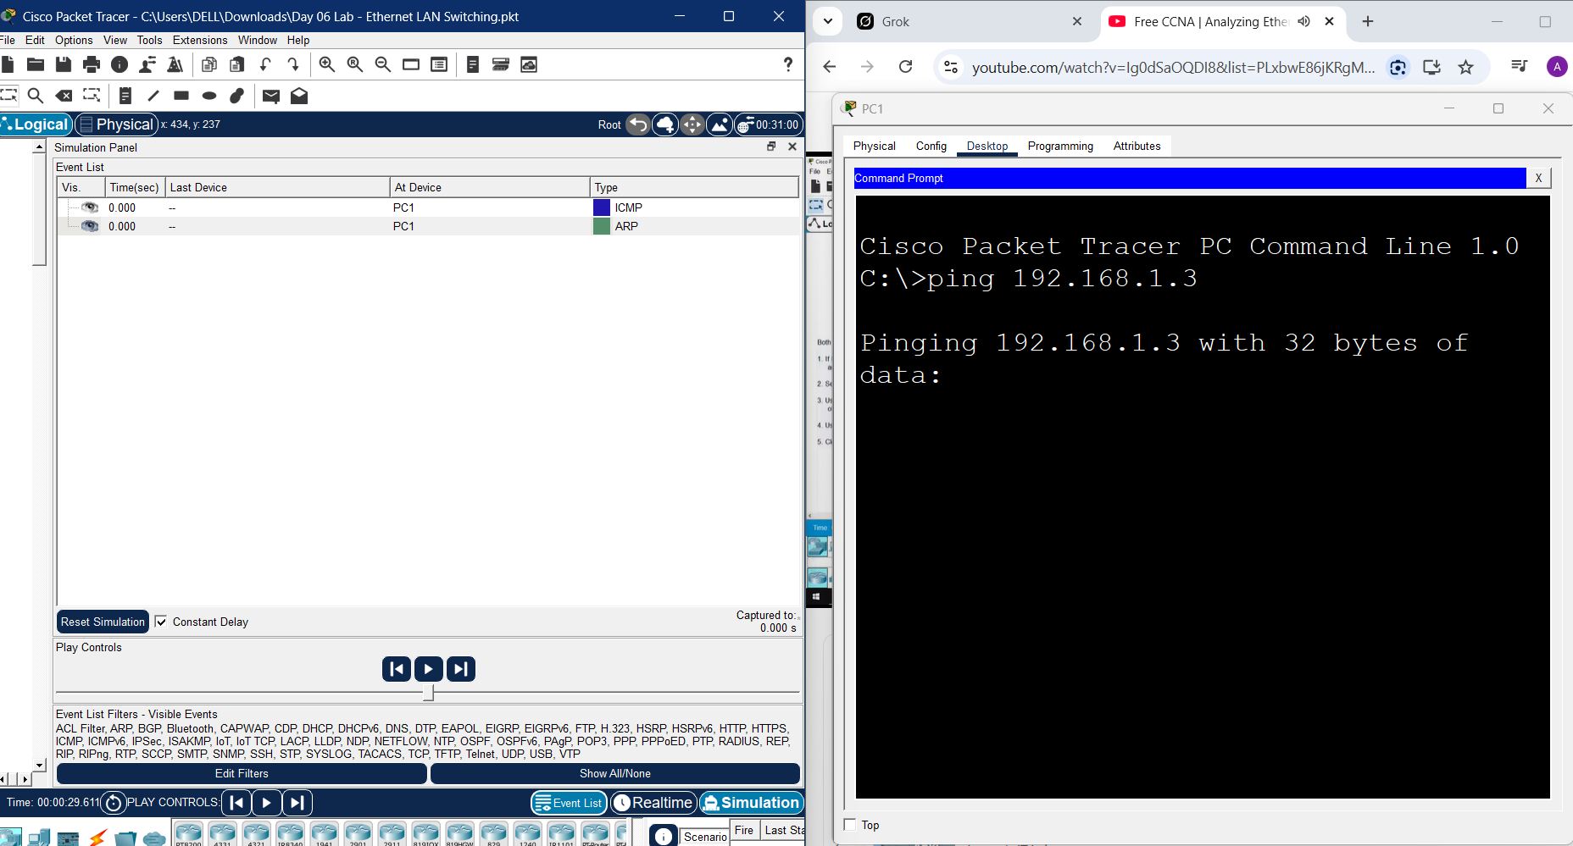

Above is an image of a packet tracer lab that illustrates the use of ping which is used to detect network connectivity in simulation mode of packet tracer . On the left hand side you can see ARP which is used by a device to get the mac address of a device it wants to communicate with, ICMP is used to determine if connectivity can happen . ARP (Address Resolution Protocol) and ICMP (Internet Control Message Protocol) differ primarily in purpose and layer: ARP maps IP addresses to physical MAC addresses on a local network (Layer 2/3), while ICMP manages network diagnostics, error reporting, and testing connectivity (Layer 3). ARP is essential for local delivery, while ICMP helps diagnose communication issues.
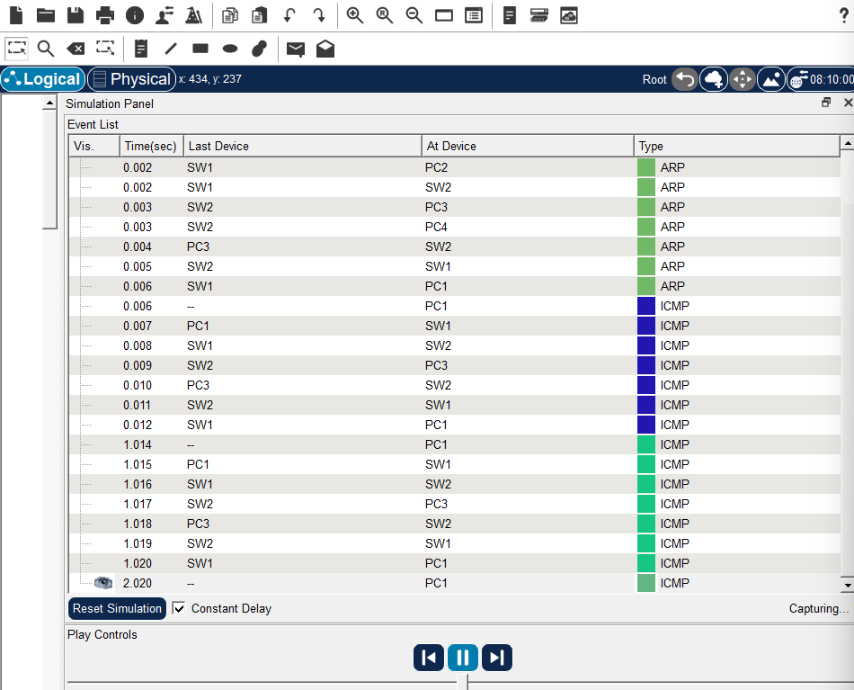
The image above shows the steps that happens when PC1 wants to communicate with other devices for example pc3. It will send an ARP request to all devices in the network to determine which on has the specific IP address it wants to communicate with. The ICMP used to detect if the connectivity can go on. If one of the devices has the IP address it will send its MAC address to PC1 and also place its MAC address in the ARP table for easy mapping.

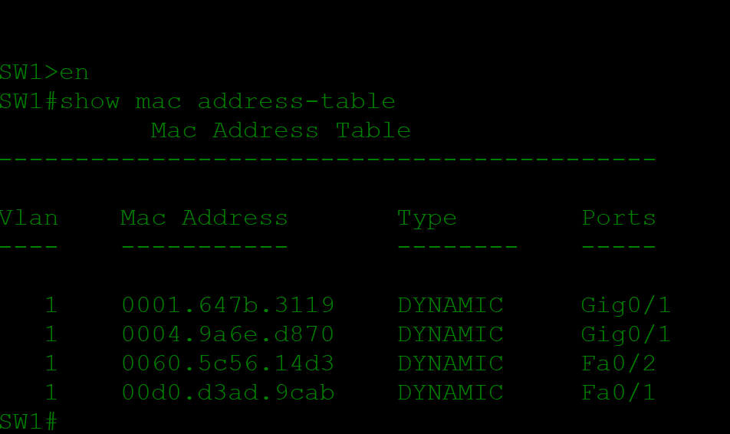

The image above is a packet tracer image where I went to privileged mode of the switch to get the mac address table by running the command show mac address-table

The image below show me after clearing the mac address table. I used the command mac address-table
s